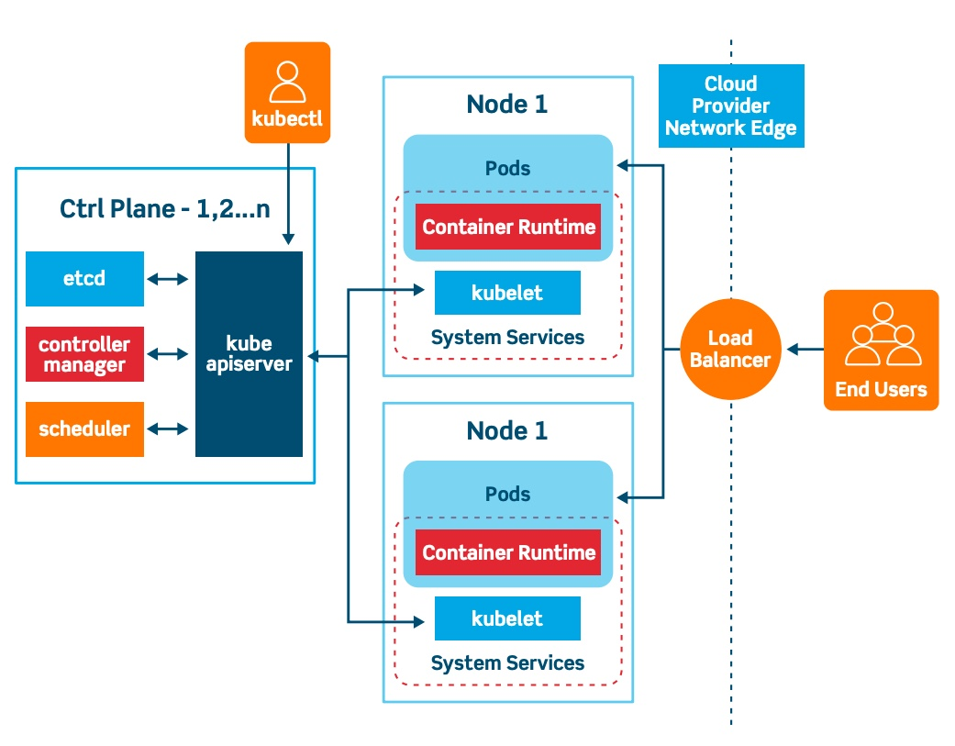
Imagine Kubernetes as a large IT company. In this company, the CEO is called kubectl. Whenever the CEO wants some work to be done, he does not directly go to employees and start working. Instead, he gives instructions to the Senior Manager, who is the API Server. For example, the CEO says:
“We need 2 new employees for the Nginx project.”
The API Server, acting as the Senior Manager, receives this request and understands what needs to be done. Before proceeding, the API Server records this information in the company database called ETCD, which works like the Accounts and Records Department. ETCD stores every important detail about the company, such as how many employees are required, which branch offices are available, and what work is currently running.
Now the Senior Manager forwards the requirement to the Scheduler, which behaves like the HR Team. The Scheduler’s responsibility is to decide which branch office has enough space and resources for the new employees. It checks all available Nodes (branch offices) and says:
“Node 1 has enough CPU and Memory. Let us place the new employees there.”
The Scheduler itself does not create employees. It only decides the best location for them. After the decision is made, the API Server informs the Kubelet present inside Node 1. Kubelet acts like the Office Administrator of that branch office. The Office Administrator receives the instruction and says:
“Okay, I will arrange the employee creation process.”
Now the Kubelet contacts the Container Runtime, which acts like the Interviewer or Hiring Team. The Container Runtime is responsible for actually hiring employees. It takes the Docker Image, which is like the employee’s resume, and starts creating Containers. Once the containers are created successfully, Kubernetes wraps them inside a Pod. In our company analogy, the Pod is the actual employee who starts doing the assigned work.
After the Pod starts running, the Kubelet continuously monitors it. Just like an Office Administrator regularly sends reports about employee health and office status to higher management, the Kubelet keeps sending Node and Pod health information back to the API Server. The API Server again stores all these updates inside ETCD.
At the same time, another important team called the Controller Manager is continuously watching the company operations. The Controller Manager behaves like an Auditor or Client Representative. Its responsibility is to ensure that the company is always maintaining the promised number of employees. For example, if the desired state says:
“2 Pods must always be running”
but suddenly one Pod crashes, then the current state becomes only 1 Pod running. The Controller Manager immediately notices the mismatch and reports:
“We are supposed to have 2 employees, but currently only 1 is working.”
Then Kubernetes automatically starts the process again to create another Pod so that the desired state matches the current state.
In this way, every component in Kubernetes works together exactly like teams inside a company. The CEO (kubectl) gives instructions, the Senior Manager (API Server) coordinates communication, the HR Team (Scheduler) decides placement, the Office Administrator (Kubelet) manages operations inside the branch office (Node), the Hiring Team (Container Runtime) creates employees (Pods), the Accounts Team (ETCD) stores records, and the Auditor (Controller Manager) ensures everything is always running correctly.

Kubernetes Architecture Explained with a Company Analogy
Imagine a big IT company where different teams and employees work together to complete tasks.
In the same way, Kubernetes also has different components that work together to deploy and manage applications.
1. kubectl → CEO of the Company
kubectl acts like the CEO. The CEO gives instructions to management rather than directly doing the work.
Example:
kubectl create deployment nginx --image=nginx
2. API Server → Senior Manager / Reception Desk
The API Server is like the Senior Manager or Reception Desk.
All requests first come here.
Responsibilities:
• Receives requests
• Validates requests
• Sends requests to correct components
• Acts as communication hub
3. Scheduler → HR Team
Scheduler works like HR.
It decides which Node has enough CPU and Memory to run Pods.
4. Node → Branch Office
A Node is like a branch office where employees actually work.
Pods run inside Nodes.
5. Kubelet → Office Administrator
Kubelet acts like the Office Administrator.
Responsibilities:
• Receives instructions from API Server
• Creates Pods
• Monitors Pod health
• Sends status updates
6. Container Runtime → Interviewer / Hiring Team
Container Runtime actually creates containers.
Examples:
• containerd
• CRI-O
• Docker
Analogy:
Resume = Docker Image
Employee Creation = Container Creation
7. Pod → Employee
Pod is like an employee.
Inside the Pod, actual work happens.
8. ETCD → Accounts Team / Company Database
ETCD stores all cluster information:
• Pod details
• Node details
• Configurations
• Secrets
• Desired State
9. Controller Manager → Auditor / Client Representative
Controller Manager ensures Current State always matches Desired State.
Example:
Desired State = 2 Pods
Current State = 1 Pod
Controller Manager notices mismatch and recreates missing Pod.
Complete Flow:
1. kubectl sends request
2. API Server receives request
3. Scheduler selects Node
4. API Server informs Kubelet
5. Kubelet talks to Container Runtime
6. Pod gets created
7. Kubelet sends health updates
8. Controller Manager ensures desired state
Mapping Table:
kubectl = CEO
API Server = Senior Manager
Scheduler = HR Team
Node = Branch Office
Kubelet = Office Administrator
Container Runtime = Interviewer
Pod = Employee
ETCD = Accounts Team
Controller Manager = Auditor
One-Line Summary:
Kubernetes works like a smart company where every team has a responsibility, and all teams coordinate together to ensure applications are always running properly.

